PROJECT REPORT
Automated Network Request Management In ServiceNow
Date | 20 September 2026
Team ID | Shaik Irshad - 238W1A4256
Project Name | Automated Network Request Management In ServiceNow

1. Introduction

1.1 Project Overview
Automated Network Request Management In ServiceNow delivers a standardized, low-code ServiceNow workflow that lets an employee raise a network-related service request through the Service Portal and have ServiceNow automatically handle backend record creation, notification, approval routing, and status tracking end to end. It is built entirely using native ServiceNow capabilities — a Service Portal catalog item, Catalog Variables, a Catalog UI Policy, a User Information Variable Set, a custom scoped-application table, and a Flow Designer flow — with no custom Script Includes, Business Rules, or external integrations.

1.2 Purpose
Conventional network-service requests handled through email, chat, or walk-in conversations lead to inconsistent information, manual data entry, difficult status tracking, manual approval coordination, and delayed notifications. The purpose of this project is to replace that fragmented process with a single, standardized ServiceNow workflow that validates and auto-populates request information, creates a traceable backend record automatically, and manages approval and status updates without manual intervention — improving consistency, visibility, and turnaround time for both the requester and the IT team.

2. Ideation Phase

2.1 Problem Statement
Two problem statements were defined using the “I am / I'm trying to / But / Because / Which makes me feel” format, capturing the requester's situation, goal, obstacle, root cause and resulting emotion.
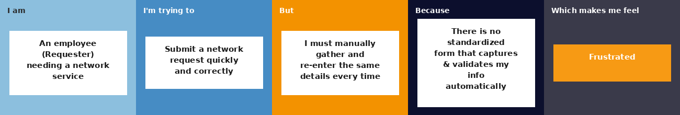
PS-1: Manual, Inconsistent Request Submission
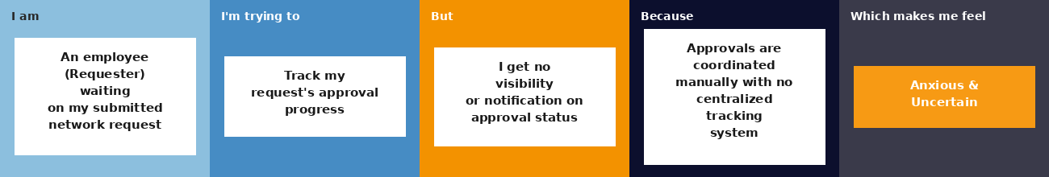
PS-2: Lack of Approval Visibility
Problem: Employees who need network-related services face a fragmented, largely manual request process where information must be collected consistently, approvals coordinated separately, and request progress is difficult to track.
Solution: A ServiceNow Service Portal-based Network Request catalog item, connected to a custom backend table and a Flow Designer automation, that handles record creation, email notification, approval, and status updates end to end.

2.2 Empathy Map Canvas
The empathy map below is built around the Requester persona — an employee submitting a network request — and is used for ideation purposes rather than as the output of a formal user study.
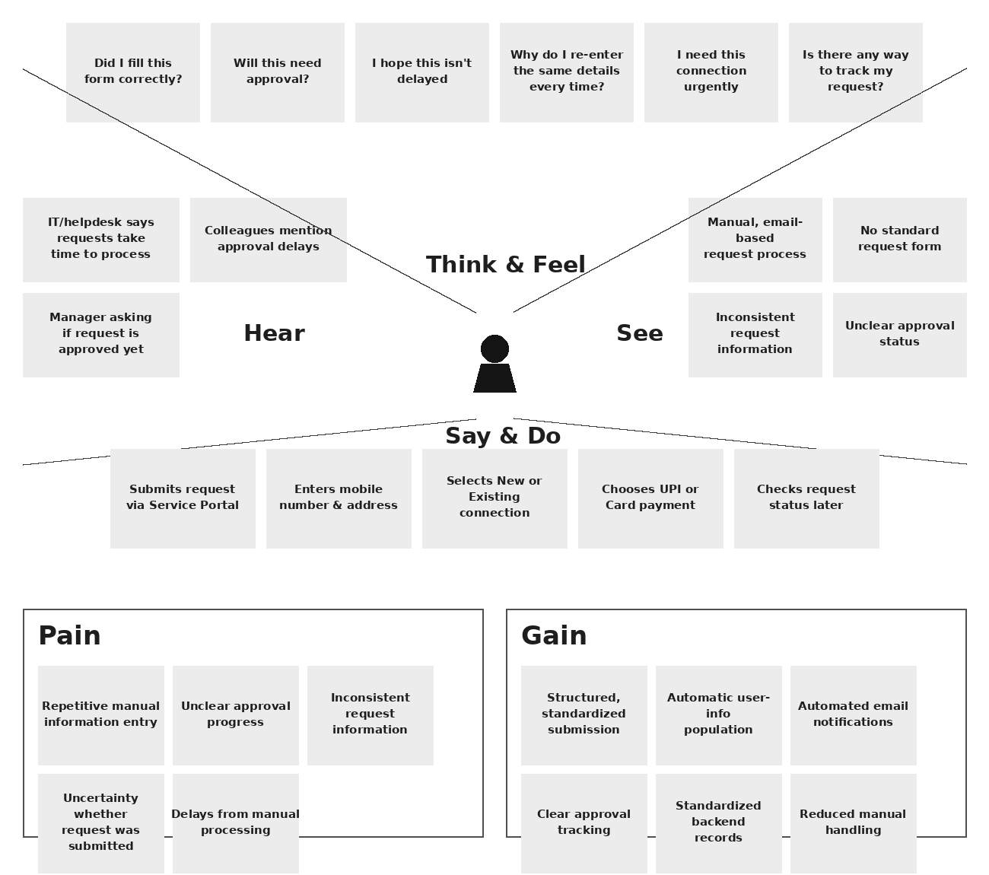

2.3 Brainstorming
Ideas were generated freely, then grouped by theme, and finally prioritized on importance versus feasibility to decide the project's actual scope.
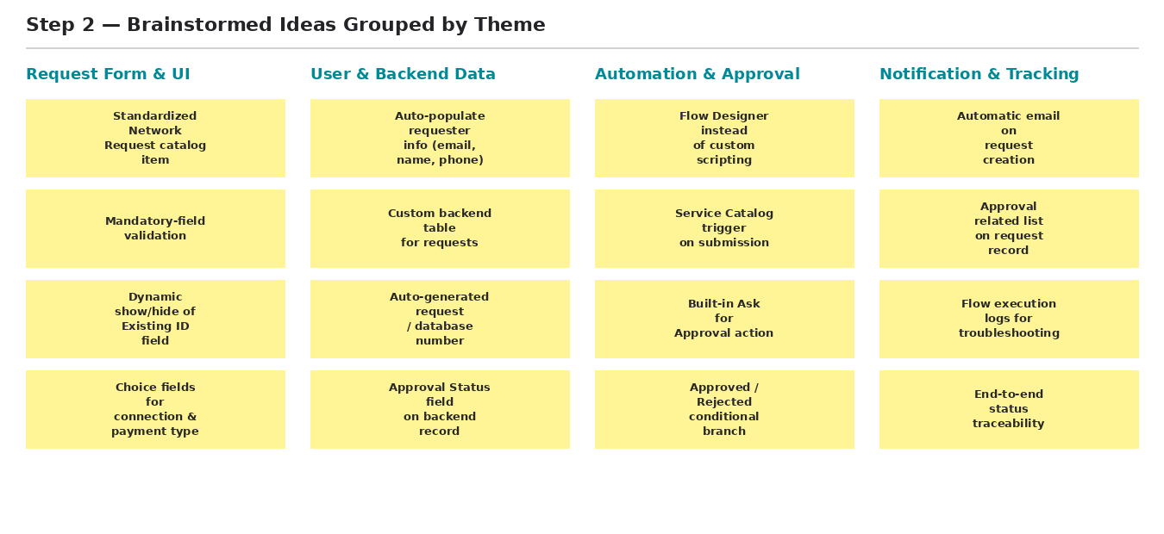
Brainstormed ideas grouped by theme
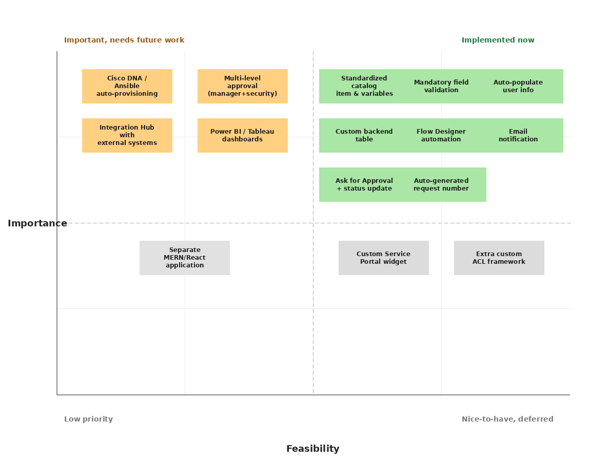
Idea prioritization: implemented now (green) vs. future enhancement (orange) vs. out of scope (grey)

3. Requirement Analysis

3.1 Customer Journey Map
The map traces the Requester's journey from first realizing a network connection is needed through to seeing the final Approved/Rejected outcome, across the phases Entice → Enter → Engage → Exit → Extend.
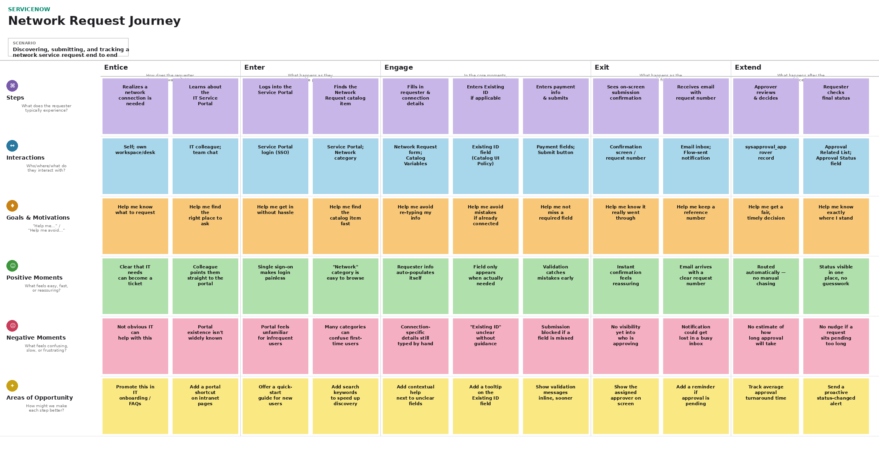

3.2 Solution Requirement
Functional Requirements:
FR No. | Functional Requirement (Epic) | Sub Requirement (Story / Sub-Task)
FR-1 | Network Request Submission | Submit a Network Request through the ServiceNow Service Portal  Enter requester, connection, payment and address details  Mandatory-field validation before submission
FR-2 | Dynamic Form Behaviour | Show the Existing ID field only when Type of Connection = Existing (Catalog UI Policy)
FR-3 | Requester Info Auto-Population | Auto-populate Email ID, User Name and Phone Number from “Opened on behalf of” (Variable Set)
FR-4 | Backend Record Creation | Create a record in the custom Database Tables table on submission  Map catalog variables to backend fields  Auto-generate the Database Number  Set initial Approval Status = Requested
FR-5 | Email Notification | Send an email to the requester with request info and the generated request number
FR-6 | Approval Workflow | Create an approval request (Ask for Approval)  Evaluate the decision and update Approval Status to Approved/Rejected
FR-7 | Status Tracking & Traceability | Display related approval records via the Approval Request relationship  Provide end-to-end visibility from submission to final status

Non-Functional Requirements:
FR No. | Non-Functional Requirement | Description
NFR-1 | Usability | A single standardized Service Portal form with mandatory-field validation and dynamic show/hide of the Existing ID field reduces confusion and repeated manual entry.
NFR-2 | Security | Access to the custom table is governed by ServiceNow's default, auto-generated ACLs; all traffic runs over the platform's standard HTTPS/TLS.
NFR-3 | Reliability | Flow Designer executes the same fixed sequence on every submission; verified using Flow Execution Details, email logs and record checks.
NFR-4 | Performance | Flow Designer runs asynchronously, so the requester's Service Portal experience is not blocked while backend processing completes.
NFR-5 | Availability | Runs on ServiceNow's SLA-backed, multi-instance cloud hosting; availability is platform-managed.
NFR-6 | Scalability | As a scoped application on the Now Platform, the solution inherits native multi-instance cloud scalability with no custom scaling logic.

3.3 Data Flow Diagram
Level-0 (context) and Level-1 (detailed) data flow diagrams describe how request data moves through the system.
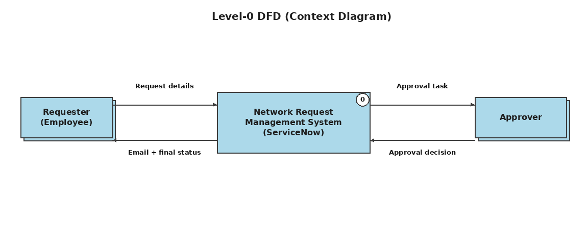
Level-0 DFD (Context Diagram)
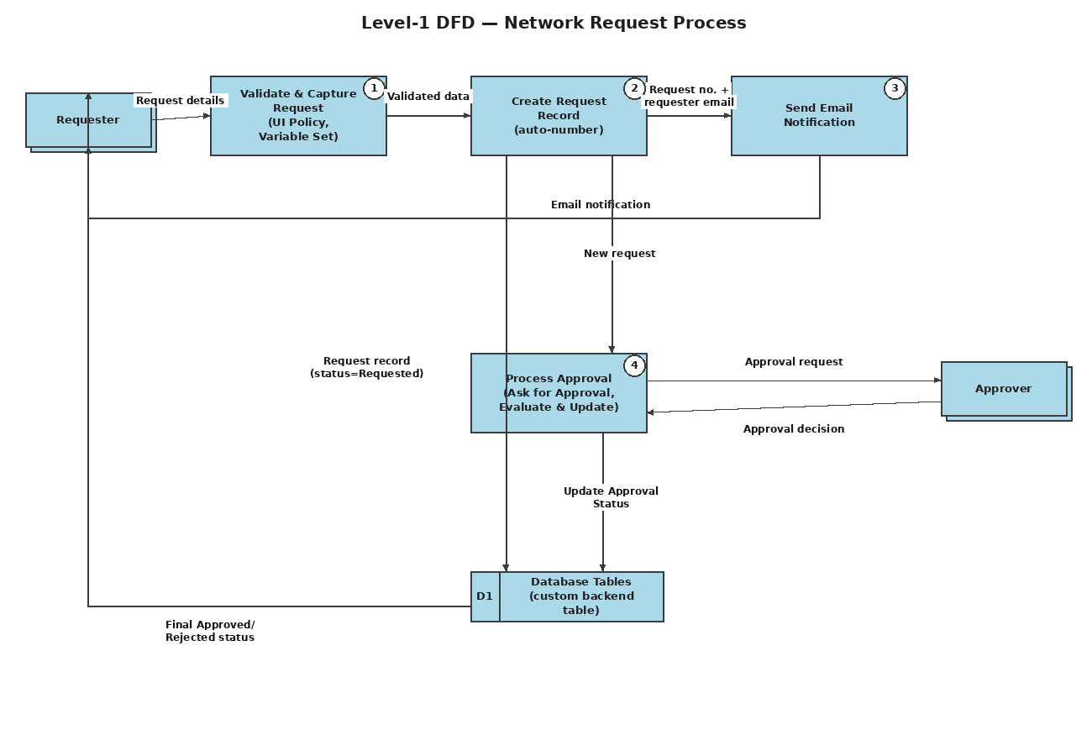
Level-1 DFD — Network Request Process

3.4 Technology Stack
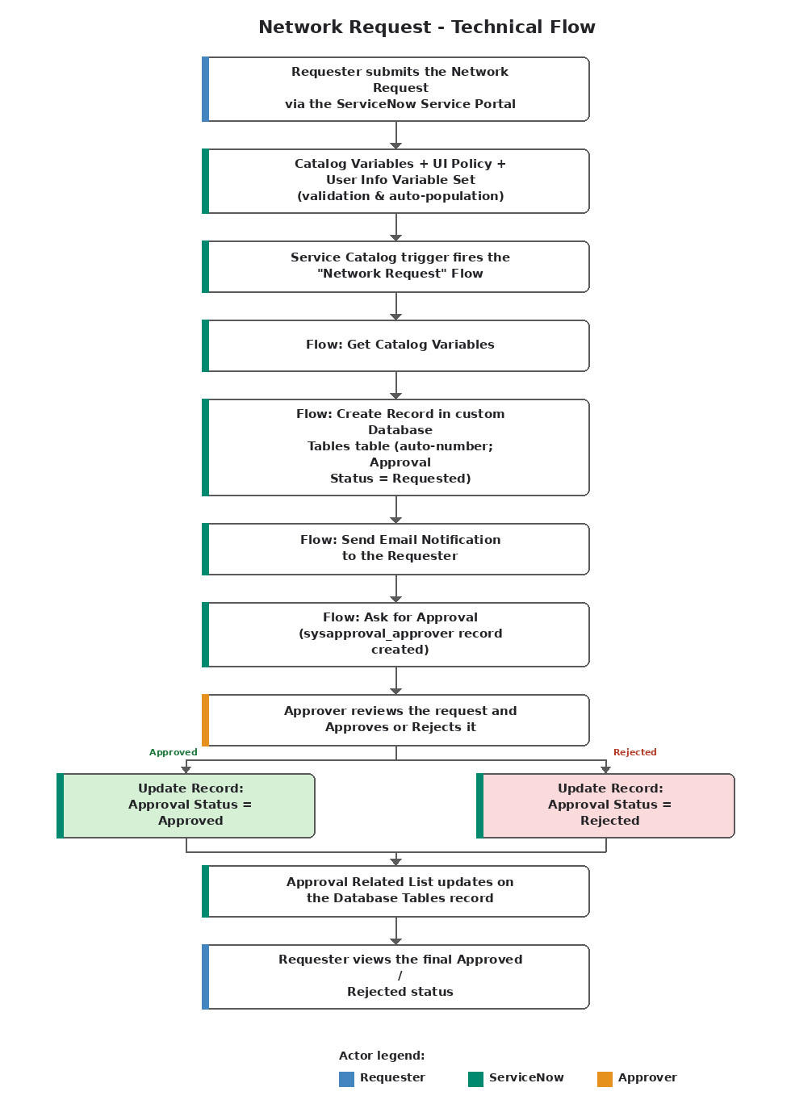
Technical flow of the Network Request implementation
S.No | Component | Description | Technology
1 | User Interface | How the requester interacts with the application | ServiceNow Service Portal - "Network Request" Catalog Item
2 | Application Logic-1 | Captures and validates/auto-populates request details | Catalog Variables, Catalog UI Policy, User Information Variable Set
3 | Application Logic-2 | Orchestrates record creation, notification and approval end to end | ServiceNow Flow Designer ("Network Request" flow)
4 | Application Logic-3 | Routes the request for approval and evaluates the outcome | ServiceNow native Approval Engine (sysapproval_approver)
5 | Database | Stores submitted network-request data | Custom "Database Tables" table in the scoped application
6 | Cloud Database | Underlying data store | ServiceNow multi-instance cloud database (no separate external DB)
7 | File Storage | Attachment storage | Not implemented — not required by the current form
8 | External API-1/2 | External systems consumed | Not implemented in this project (see Future Scope)
9 | Machine Learning Model | ML usage | Not applicable / not implemented
10 | Infrastructure | Where the app is deployed | ServiceNow multi-tenant cloud instance, fully platform-managed

4. Project Design

4.1 Problem Solution Fit
The Problem-Solution Fit canvas checks that the realized ServiceNow solution actually addresses the requester's real behaviour, constraints and triggers.
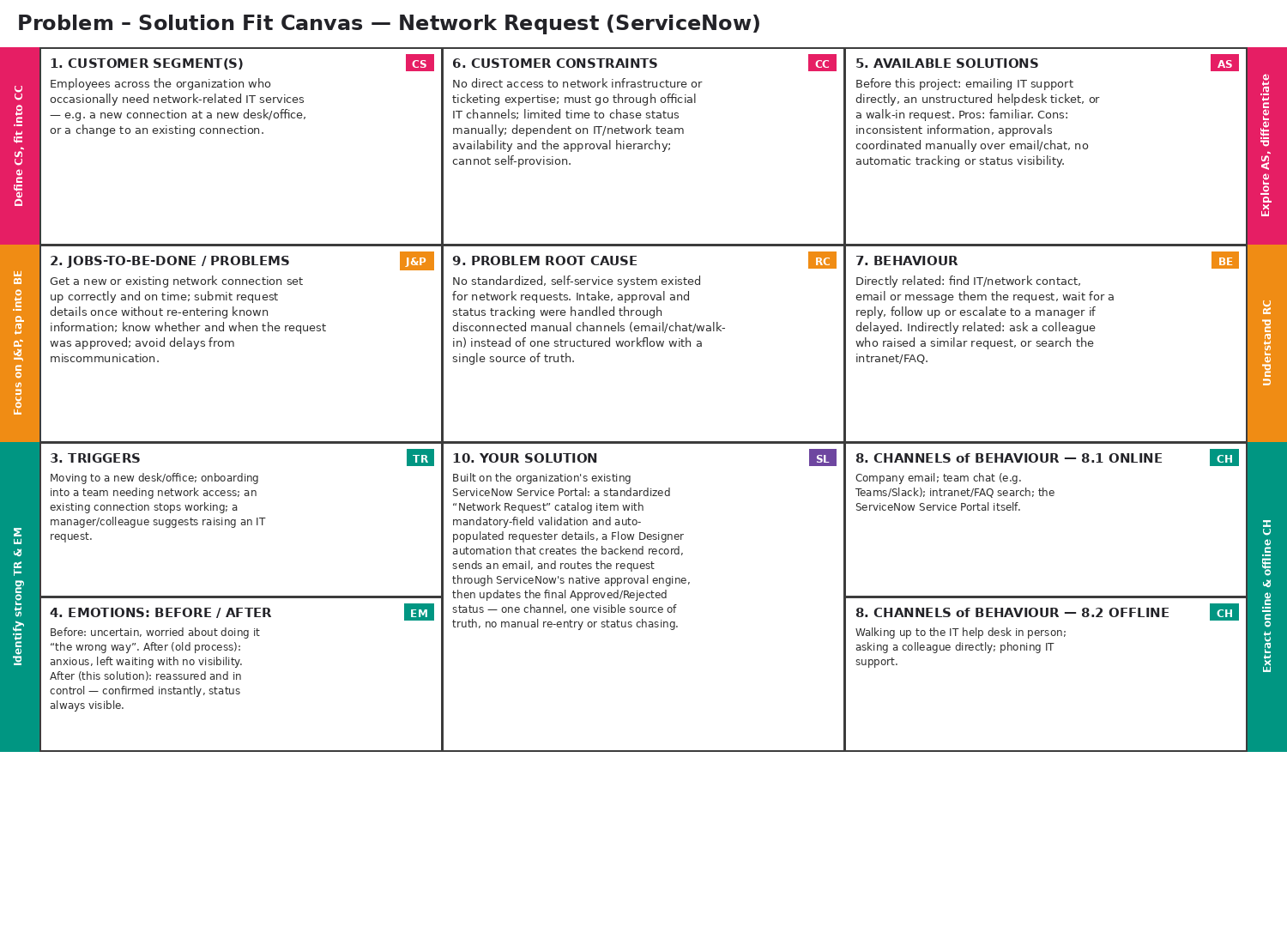

4.2 Proposed Solution
S.No. | Parameter | Description
1 | Problem Statement | - Employees face a fragmented, manual network-request process with inconsistent information, manual approval coordination, and poor status visibility.
2 | Idea / Solution | - Standardized Service Portal catalog item with validation and dynamic fields; auto-populated requester info; Flow Designer creates the backend record, sends email, and manages approval; full traceability via the Approval Request relationship.
3 | Novelty / Uniqueness | - A fully configuration-first, low-code build — no custom Script Includes or Business Rules — using only native ServiceNow capabilities end to end.
4 | Social Impact / Customer Satisfaction | - Removes repetitive manual entry, gives automatic confirmation, and provides clear approval visibility, reducing follow-up queries and turnaround time.
5 | Business Model | - An internal IT-efficiency solution: value comes from reduced IT support hours and fewer errors, not direct revenue; could be packaged as a reusable accelerator as a future direction.
6 | Scalability | - Runs natively on ServiceNow's multi-instance cloud; the same pattern can be extended to other IT service requests by cloning the existing components.

4.3 Solution Architecture
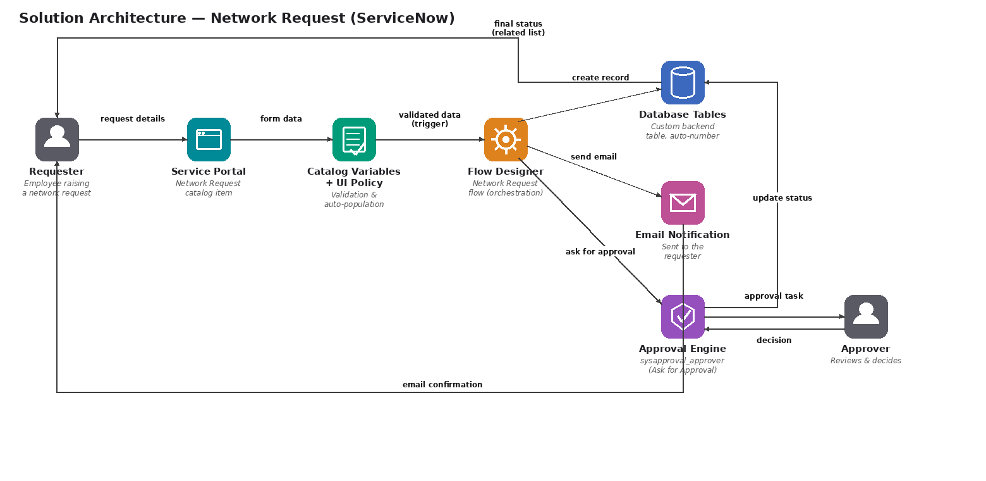

5. Project Planning & Scheduling

5.1 Project Planning
Product Backlog:
Sprint | Epic | Story No. | User Story | Points | Priority
Sprint-1 | Network Request Submission | USN-1 | As a requester, I can open the Network Request catalog item and enter my request details. | 2 | High
Sprint-1 | Network Request Submission | USN-2 | As a requester, I cannot submit the request if a mandatory field is left blank. | 1 | High
Sprint-1 | Network Request Submission | USN-3 | As a requester, I can select whether my connection is New or Existing. | 1 | High
Sprint-1 | Dynamic Form Behaviour | USN-4 | As a requester, I only see the Existing ID field when I select Existing connection. | 2 | Medium
Sprint-1 | Requester Info Auto-Population | USN-5 | As a requester, my email, name and phone number are auto-populated. | 2 | Medium
Sprint-1 | Backend Configuration | USN-11 | As an admin, I can see all submitted requests as structured records in one table. | 3 | Medium
Sprint-2 | Email Notification | USN-6 | As a requester, I receive an email once my request has been created. | 2 | High
Sprint-2 | Status Tracking & Traceability | USN-7 | As a requester, I can check whether my request is pending, Approved, or Rejected. | 2 | High
Sprint-2 | Approval Workflow | USN-8/9/10 | As an approver, I receive, review, and decide on requests, which updates the final status. | 4 | High
Sprint-2 | Backend Configuration | USN-12 | As an admin, I can trace an approval back to its request record. | 2 | Medium
Sprint-2 | Security & Access | USN-13 | As an admin, the table is secured using default ACLs without a custom framework. | 1 | Low
Sprint-2 | Troubleshooting | USN-14 | As an admin, I can diagnose why a submission did not trigger automation. | 2 | Medium

Sprint Schedule:
Sprint | Total Points | Duration | Start Date | End Date (Planned) | Points Completed | Release Date (Actual)
Sprint-1 | 11 | 6 Days | 01 Aug 2026 | 06 Aug 2026 | 11 | 06 Aug 2026
Sprint-2 | 13 | 6 Days | 08 Aug 2026 | 13 Aug 2026 | 13 | 13 Aug 2026

Velocity: with a 6-day sprint duration and 24 combined story points across two sprints, AV = Velocity / Sprint Duration = 24 / 12 = 2 story points/day.
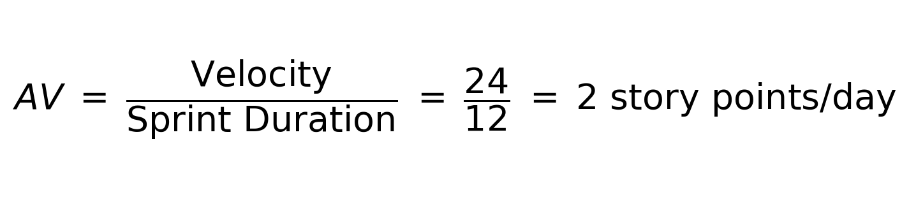
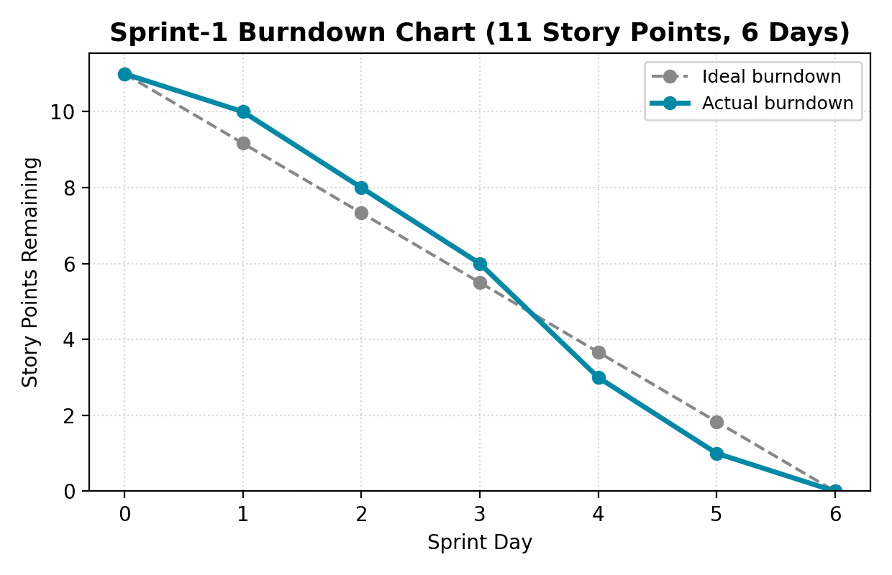
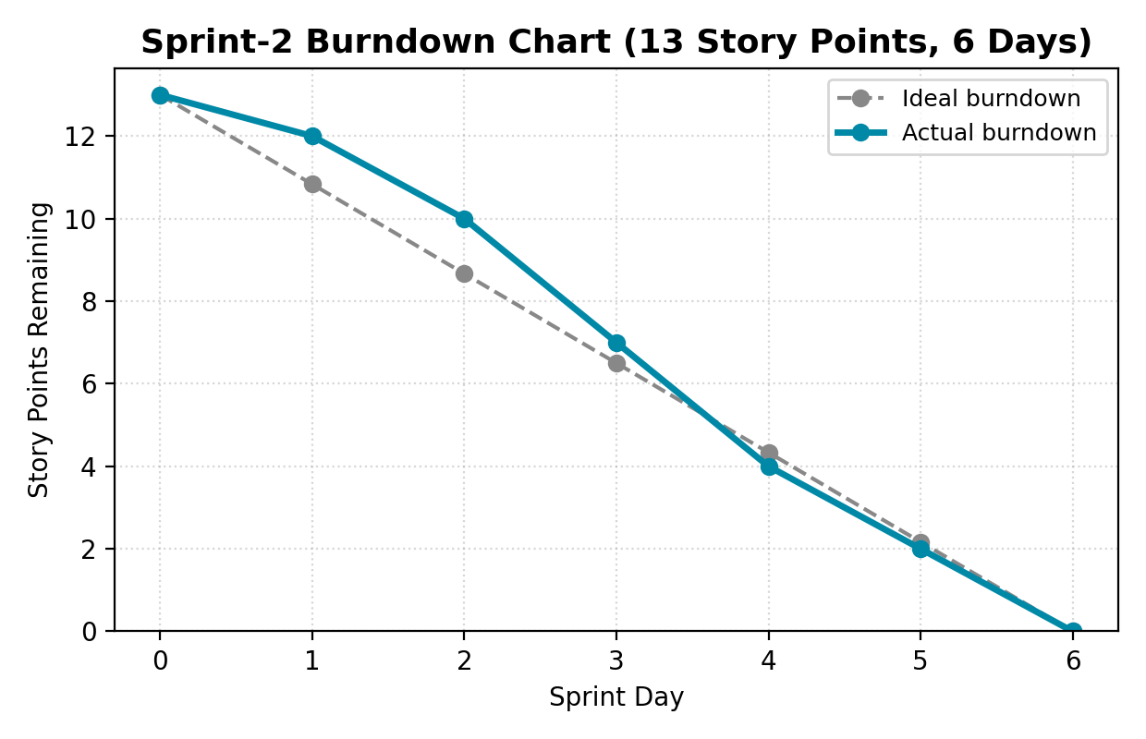
Sprint-1 and Sprint-2 burndown charts — both sprints completed on schedule

6. Functional and Performance Testing
The table below lists the functional test cases executed via actual Service Portal submissions, covering validation, dynamic behaviour, backend record creation, notification, and the approval workflow.
Test Case ID | Description | Expected Result | Actual Result | Status
TC-01 | Submit with a mandatory field left blank | Submission is blocked with a validation message | Blocked as expected | Pass
TC-02 | Select ‘Existing’ connection type | “Enter your Existing ID” field becomes visible | Field appeared | Pass
TC-03 | Select ‘New’ connection type | Existing ID field stays hidden | Field hidden | Pass
TC-04 | Set ‘Opened on behalf of’ | Email, User Name and Phone Number auto-populate | Auto-populated correctly | Pass
TC-05 | Submit a fully valid request | New record created in Database Tables with a unique auto-number | Record created with number | Pass
TC-06 | Check newly created record | Approval Status = Requested | Status = Requested | Pass
TC-07 | Submit a valid request | Requester receives an email with the request number | Email received | Pass
TC-08 | Submit a valid request | sysapproval_approver record created and linked via the Approval Request relationship | Approval record linked | Pass
TC-09 | Approver approves the request | Approval Status updates to Approved | Status updated | Pass
TC-10 | Approver rejects the request | Approval Status updates to Rejected | Status updated | Pass
TC-11 | Submit via Service Portal (initial catalog item/flow link) | Flow executes automatically on submission | Initially did not trigger; passed after correcting the catalog item’s Flow/Process Engine association (see Troubleshooting) | Pass (after fix)
TC-12 | A different user views another requester’s record | Access governed by ServiceNow's default ACLs | Access controlled as expected | Pass

6.1 Performance Testing
As a solution built entirely on ServiceNow's managed SaaS platform, performance testing was scoped to what the project team could directly observe rather than infrastructure load-testing:
- Flow Designer executes asynchronously, so the Service Portal submission returns to the requester immediately without waiting on record creation, email, or approval steps.
- During testing, the time from submission to backend record creation and email dispatch was consistently within a few seconds.
- Approval creation and status-update steps were verified through Flow Execution Details with no noticeable delay.
- No formal load or stress testing (e.g. many concurrent submissions) was conducted, as scaling and infrastructure performance are managed by the ServiceNow platform itself and were outside this project's scope.

7. Results

7.1 Output Screenshots
This section should contain screenshots captured directly from your ServiceNow instance — they cannot be generated on your behalf without access to your live instance. Please insert screenshots of the following before final submission:
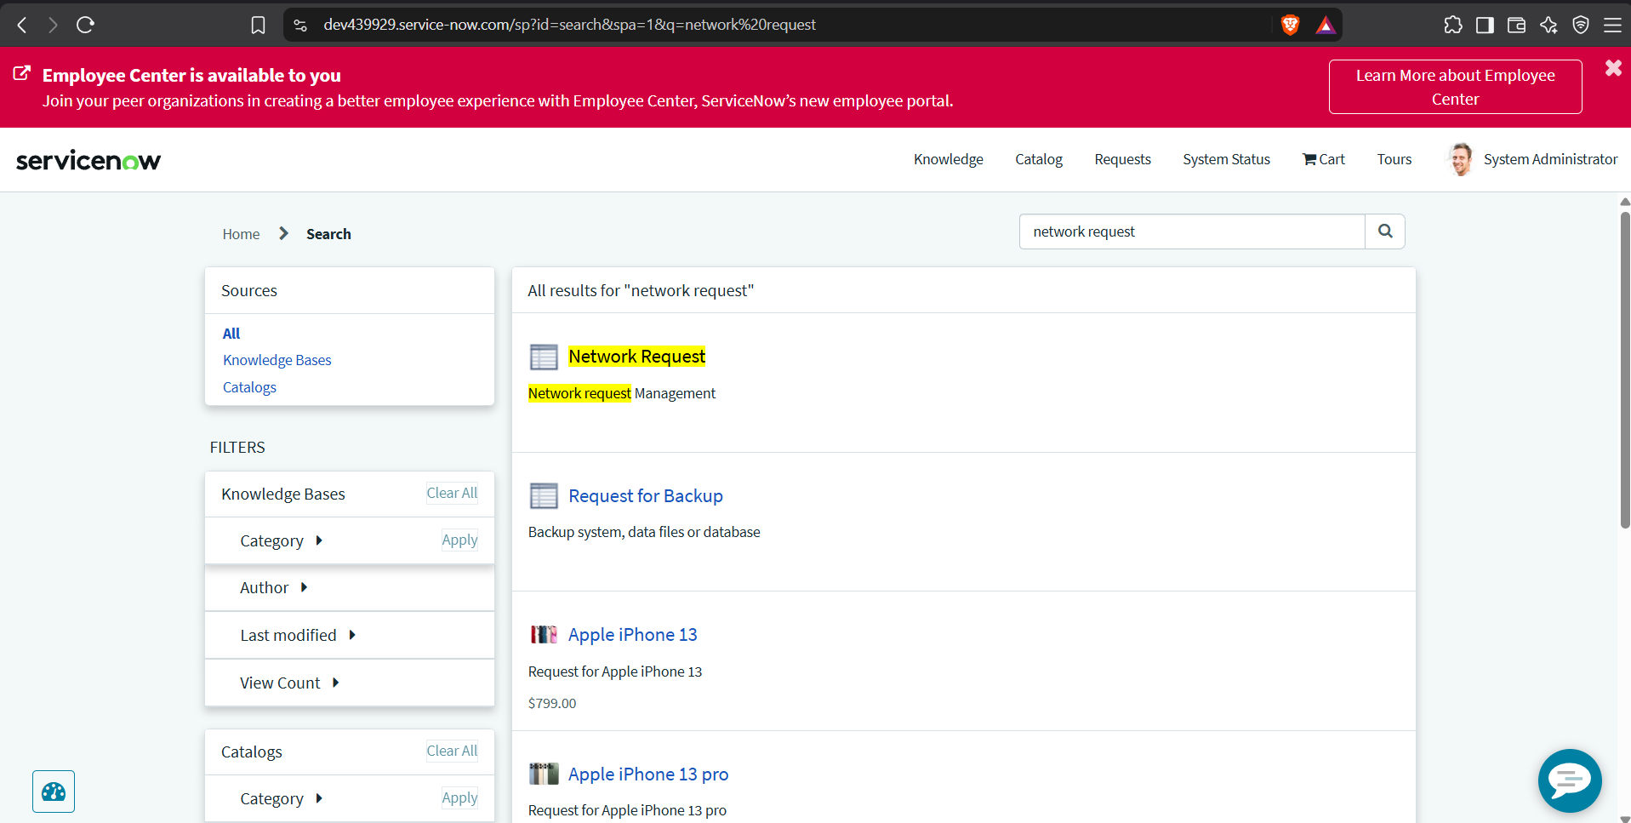
Fig-1:The Network Request catalog item as seen in the Service Portal
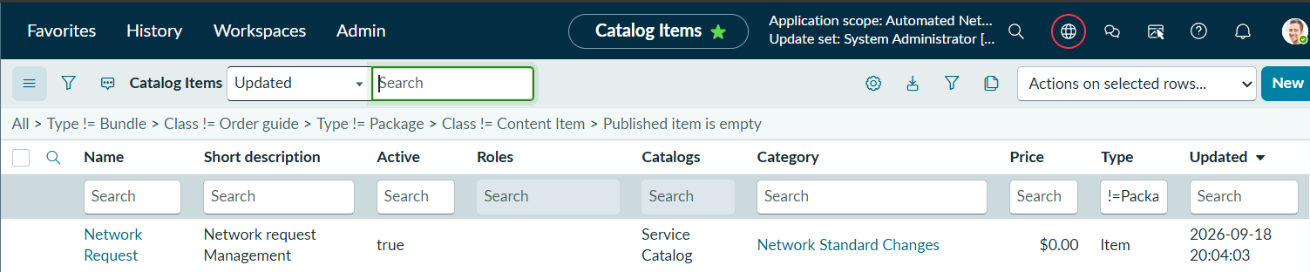
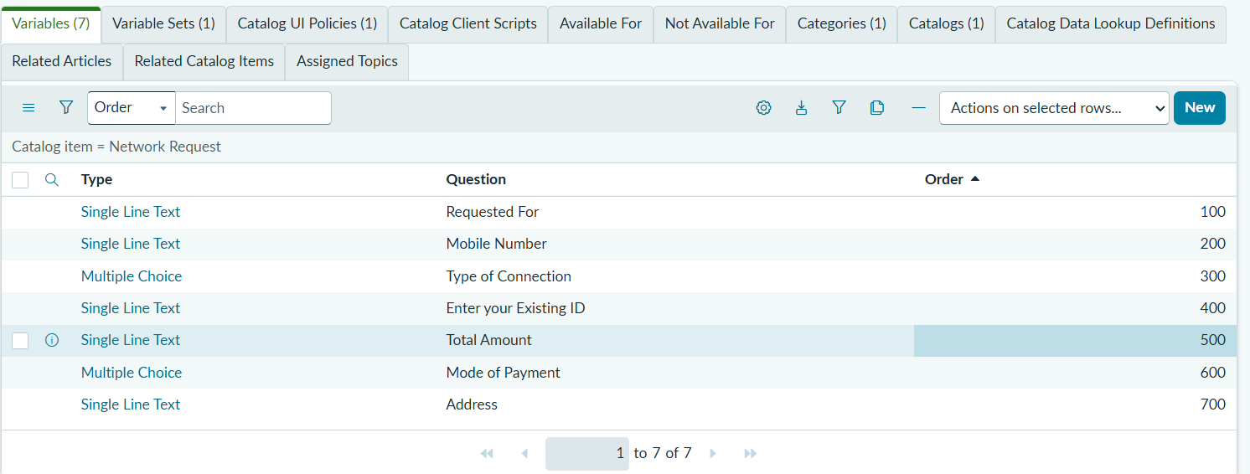
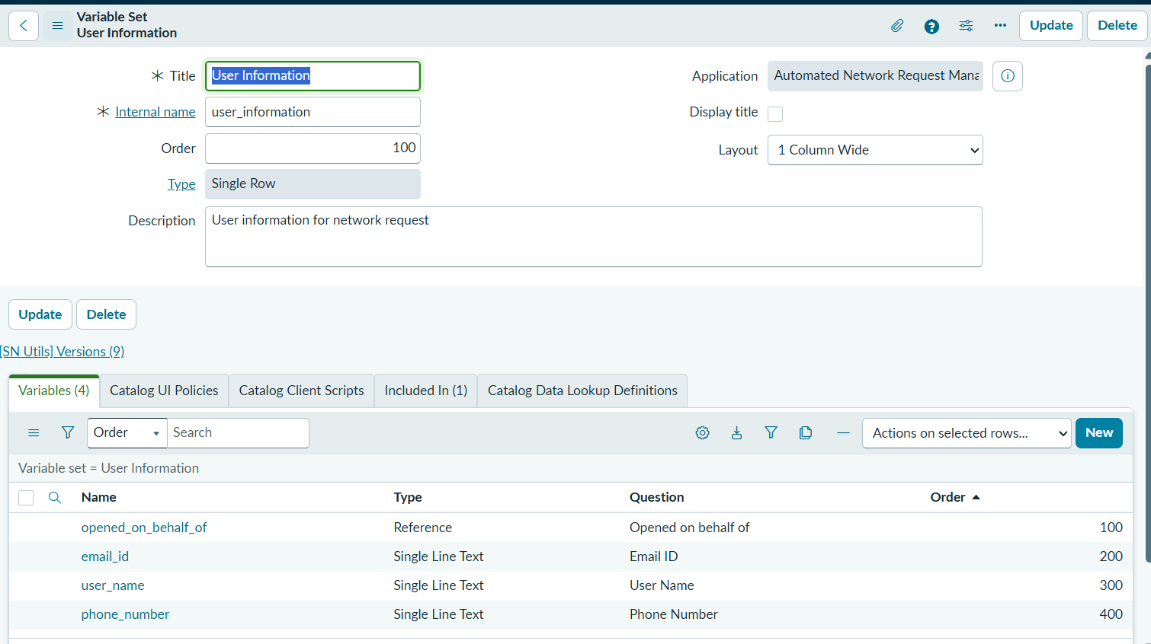

Fig-2: Catalog variable configuration and the User Information variable set

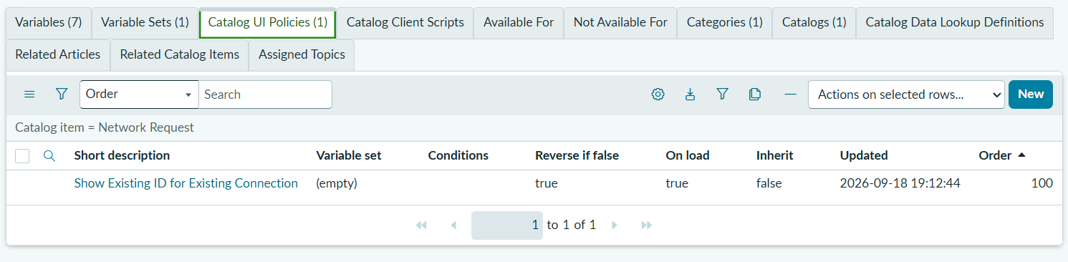
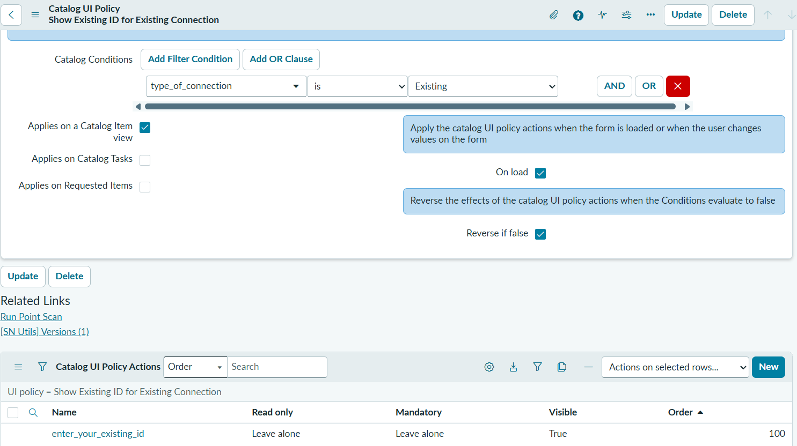
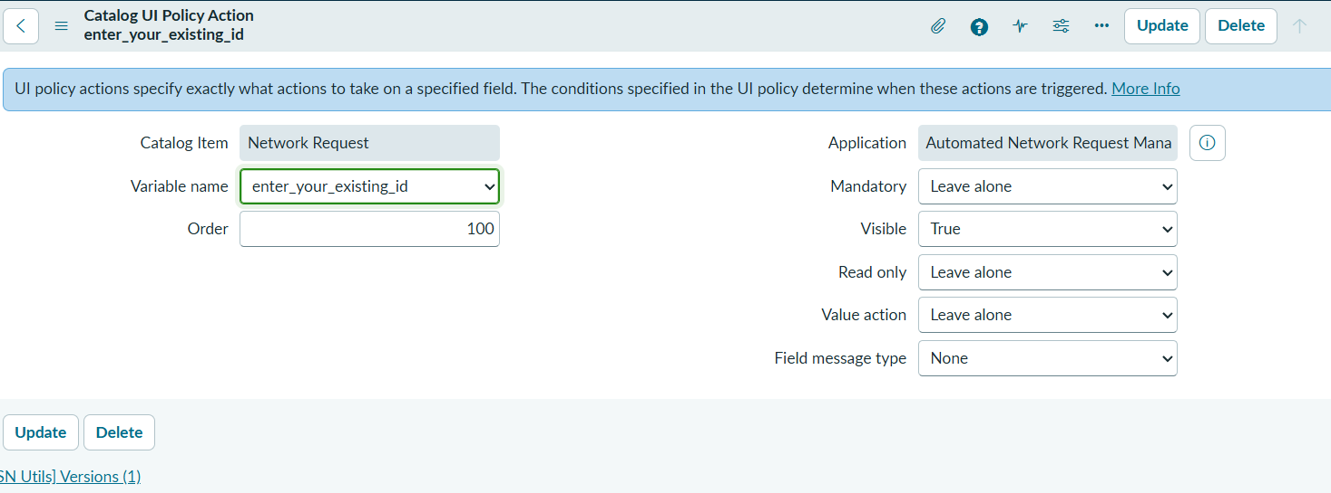
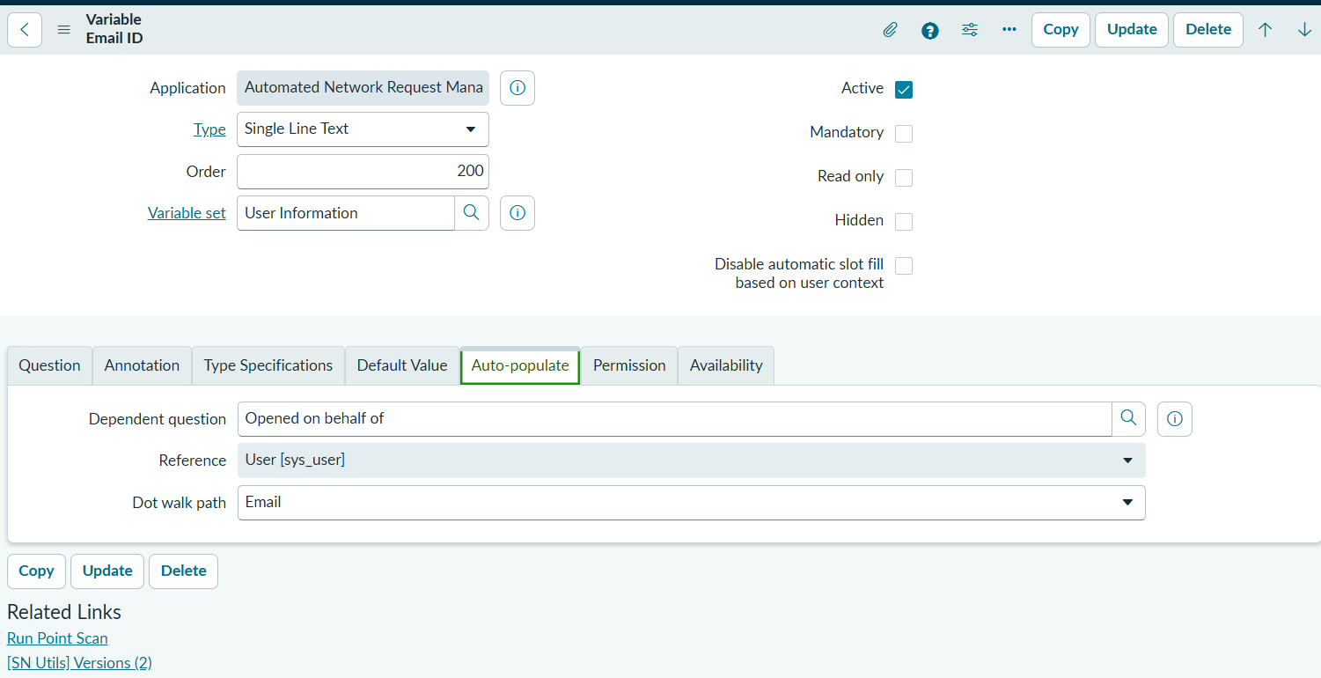
Fig-3: The Catalog UI Policy and the Existing ID field's dynamic show/hide behaviour
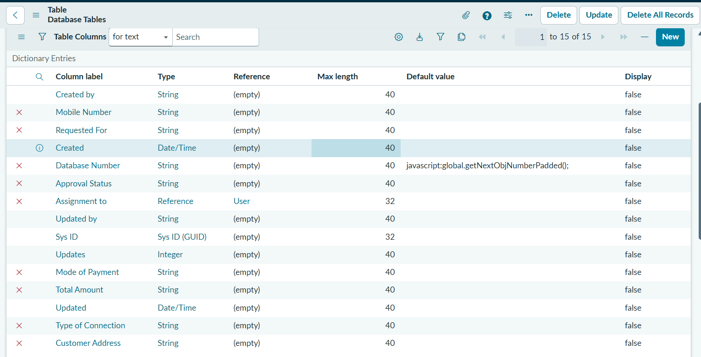
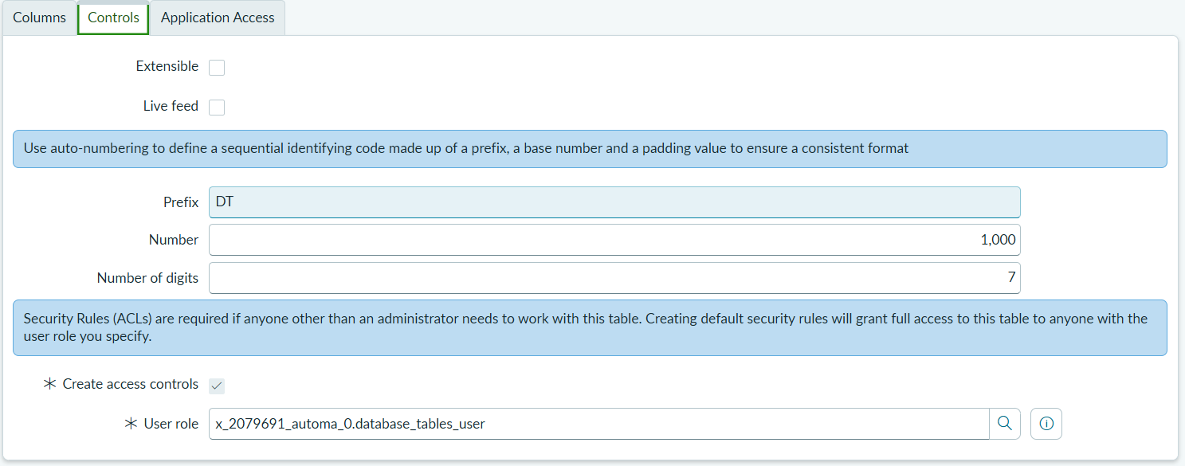
Fig-4: The Database Tables table, its fields, and the auto-number configuration

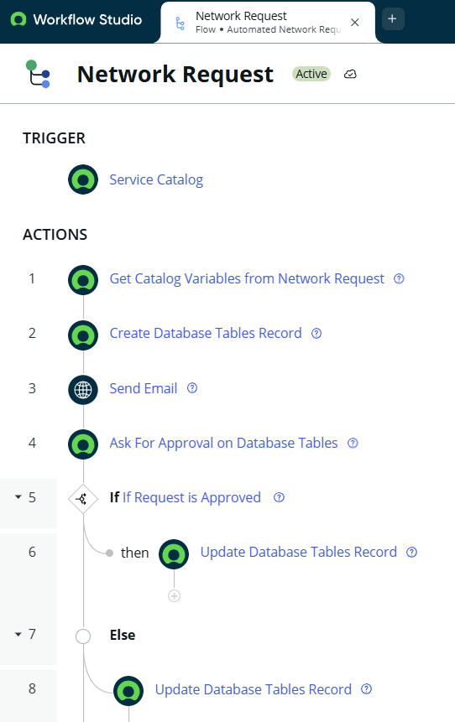
Fig-5: The Flow Designer canvas showing the complete “Network Request” flow

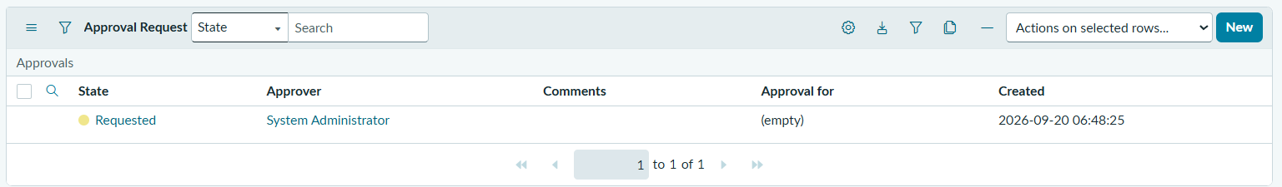
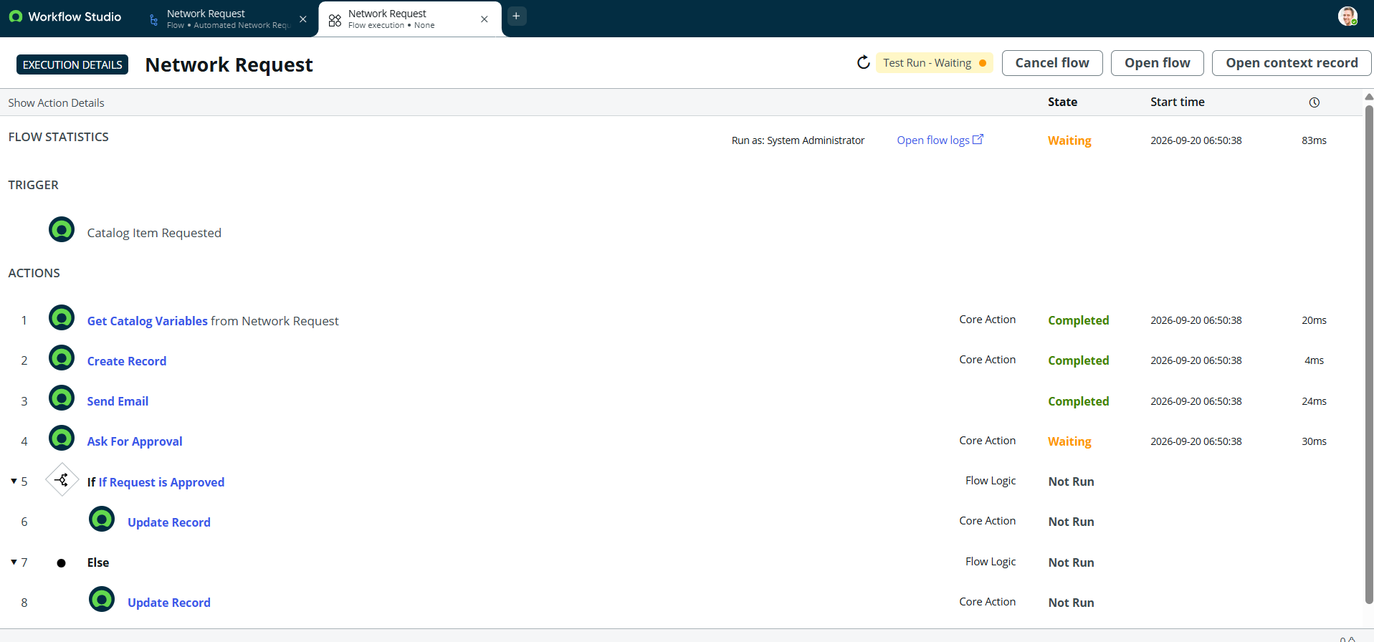
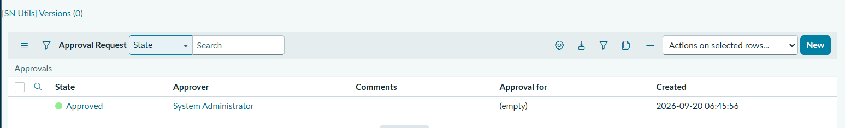
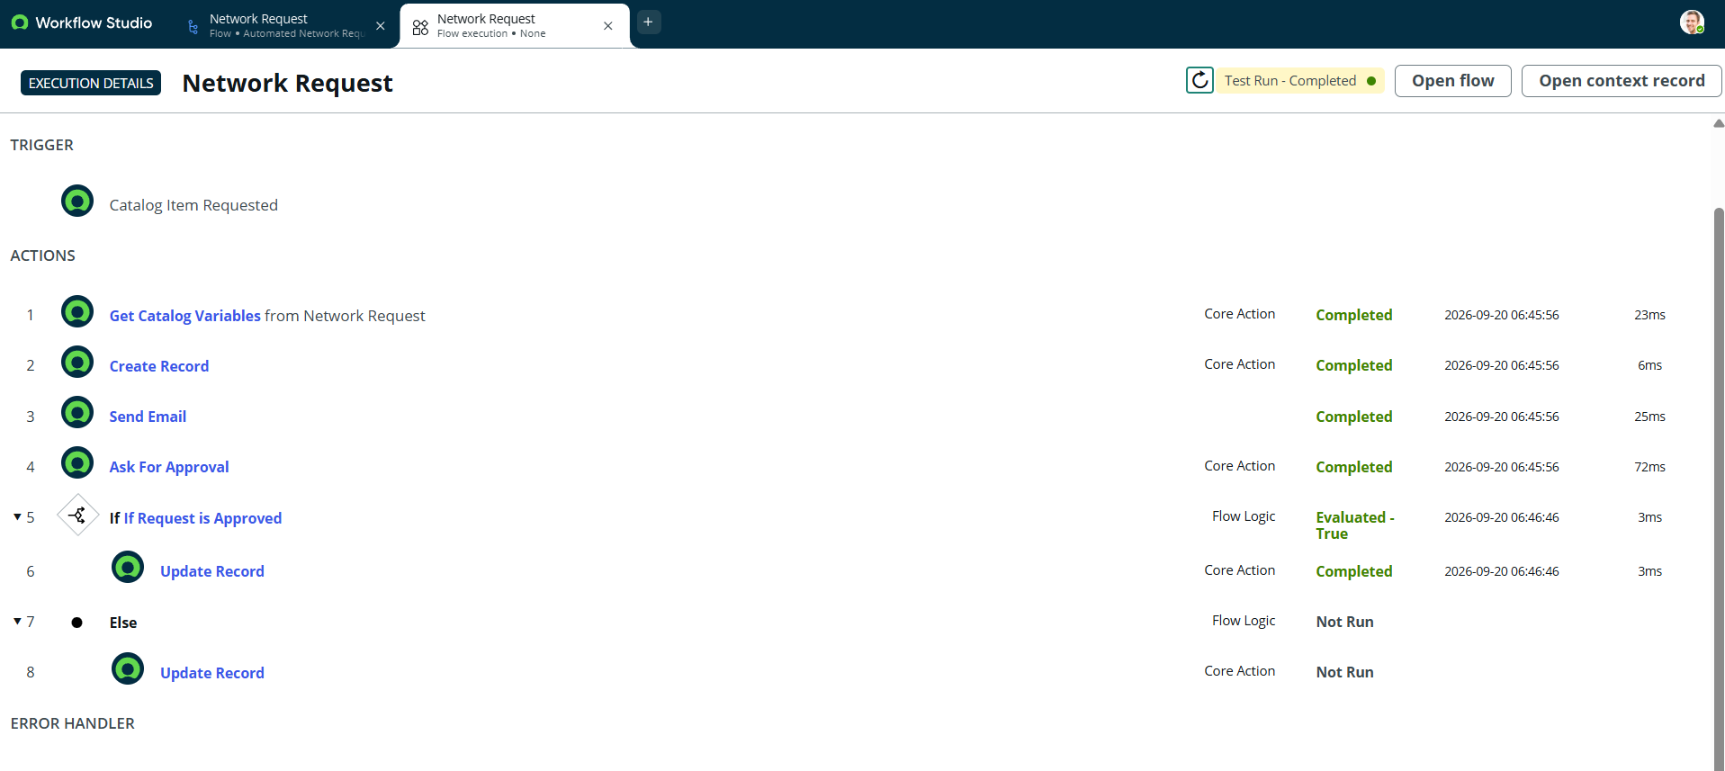

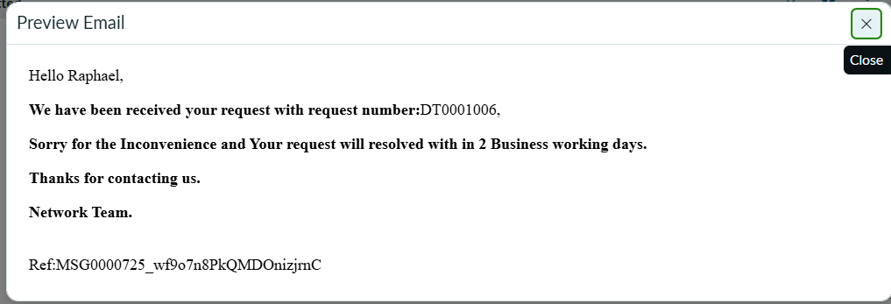
Fig-6: A submitted request record, the generated email notification, and the approval record
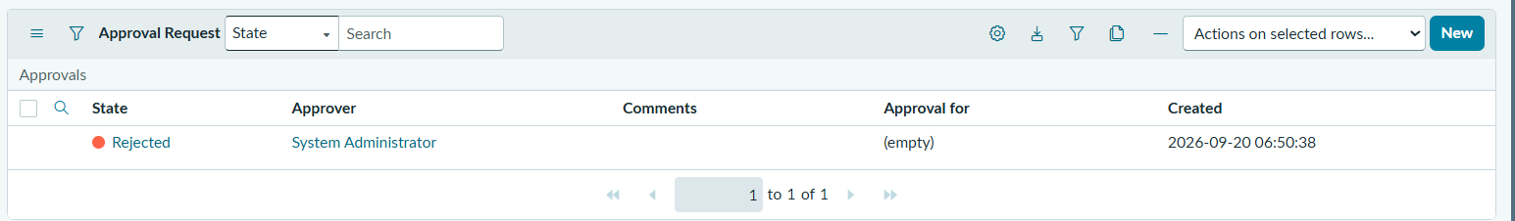
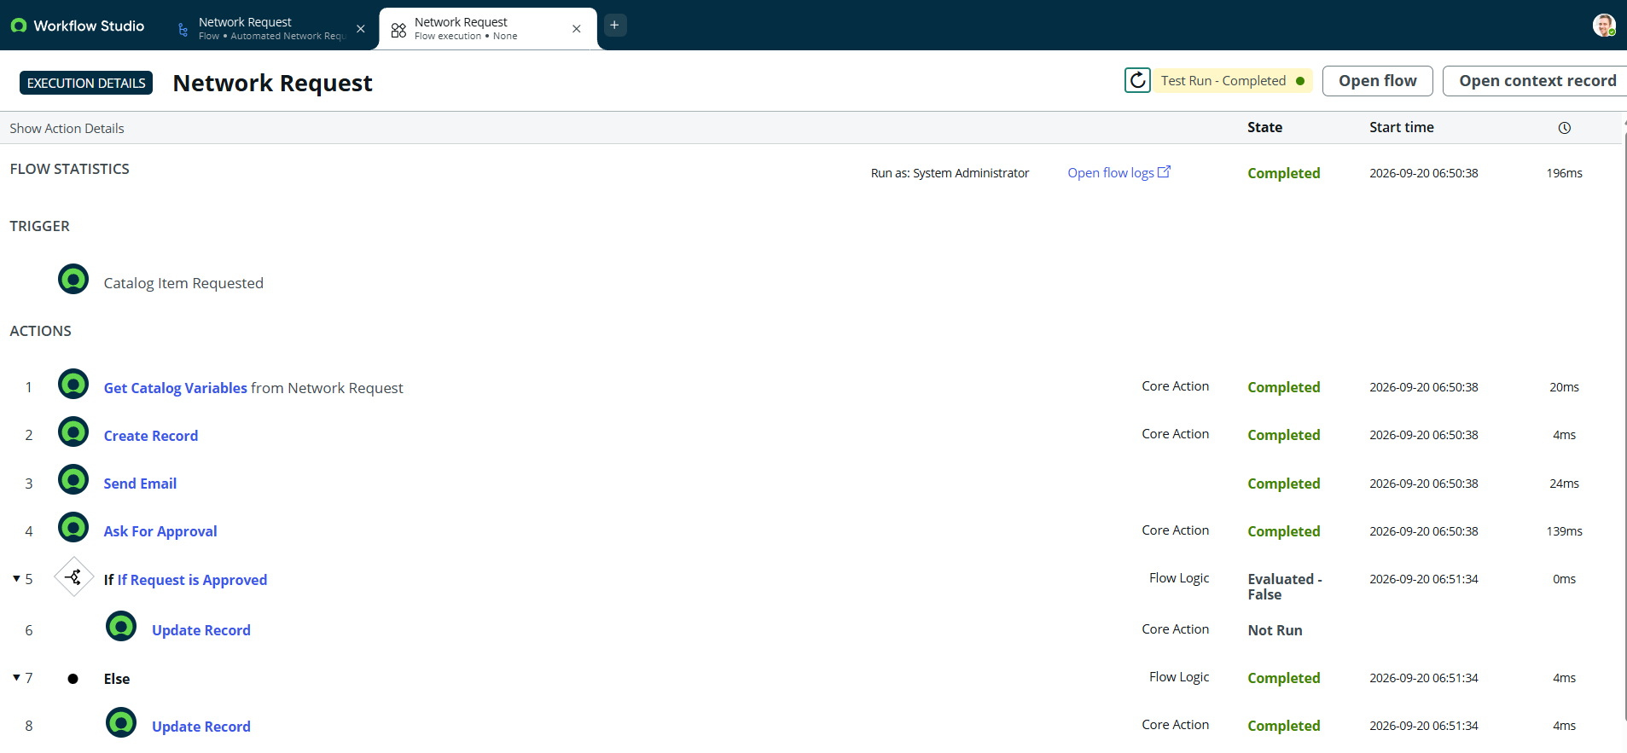
Fig-7: Approved and Rejected outcomes, and the Approval Related List on a request record

8. Advantages & Disadvantages

Advantages
- A single standardized entry point eliminates inconsistent request information.
- Low-code build (no custom scripts) keeps long-term maintenance overhead low.
- End-to-end traceability from submission through approval to final status.
- Automatic notifications and auto-population reduce manual effort and data-entry errors.
- Inherits ServiceNow's native, SLA-backed multi-instance cloud scalability and default security (ACLs) at no extra build cost.
- The same pattern can be reused for other IT service requests with minimal rework.

Disadvantages
- The approval workflow uses a single “Anyone approves” rule with one approver used during testing, not a multi-level manager/security hierarchy.
- No integration with real network-device provisioning systems (e.g. Cisco DNA Centre, Ansible); approval does not trigger actual device configuration.
- Some connection-specific details still require manual entry by the requester.
- No reporting or analytics dashboard exists yet for tracking request volume or approval turnaround over time.
- The solution depends on ServiceNow platform availability and licensing rather than being a standalone application.
- No formal load/performance testing at scale was conducted.

9. Conclusion
This project successfully replaced a manual, fragmented network-request process with a standardized, low-code ServiceNow workflow. Using only native ServiceNow capabilities — a Service Portal catalog item, Catalog Variables, a Catalog UI Policy, a User Information Variable Set, a custom backend table, and a Flow Designer flow — the solution validates and auto-populates request information, creates a traceable backend record automatically, sends notifications, and manages the full approval lifecycle without manual coordination. End-to-end testing confirmed that mandatory-field validation, dynamic form behaviour, auto-population, record creation, email notification, and the Approved/Rejected decision path all function correctly, and a real troubleshooting event (the catalog item's Flow/Process Engine association) was identified and resolved during development. The result meets the project's original objectives: a standardized request form, automatic backend processing, and full traceability from submission to final status.

10. Future Scope
The following are realistic next steps identified during brainstorming and prioritization, but were not part of this project's delivered scope:
- Network automation integration (Cisco DNA Centre, Ansible) so an approved request could trigger real device configuration.
- ServiceNow Integration Hub connections to external network-management systems.
- Reporting dashboards (e.g. Power BI or Tableau) for request volume, approval turnaround time, and completion statistics.
- Extending the same catalog item + variable set + UI Policy + Flow Designer + Approval Engine pattern to other IT services, such as device provisioning, access requests, and other infrastructure requests.

11. Appendix

Source Code (if any)
This project is delivered primarily through ServiceNow configuration — Catalog Variables, a Catalog UI Policy, a Variable Set, and a Flow Designer flow — rather than custom scripts. There are no custom Script Includes or Business Rules to include as source code. If required by evaluators, export the Update Set XML for the scoped application and attach it separately, or include configuration screenshots in Section 7.1.

Dataset Link
Not applicable — the project does not use an external dataset. All data is generated from user-submitted requests through the ServiceNow Service Portal.

GitHub & Project Demo Link
GitHub repository: https://github.com/irshad56/automated-network-request-management.git
Project demo video link(Detailed): https://drive.google.com/file/d/1Z6P_lSzeWeHzCpK2lcalsE-QAzAkEPw1/view?usp=sharing

